Sabaragamuwa University of Sri Lanka



Capstone Project in Data Science – DS4105
An End-to-End Machine Learning Pipeline for Rice Price Forecasting in Sri Lanka

A Project Report submitted to the Faculty of Computing, Sabaragamuwa University of Sri Lanka, in partial fulfillment of the requirements for the Degree of Bachelor of Science Honours in Data Science.

Student Name | Mohomed Yoosuf
Index Number | 22CDS0403
Supervisor Name | Prof. BTGS Kumara

DEPARTMENT OF DATA SCIENCE
FACULTY OF COMPUTING

August 20, 2026

Declaration
I declare that this thesis does not incorporate, without acknowledgment, any material previously submitted for a Degree or a Diploma in any University, and to the best of our knowledge and belief, it does not contain any material previously published or written by another person or ourself except where due reference is made in the text. Also, I hereby grant to Sabaragamuwa University of Sri Lanka the non-exclusive right to reproduce and distribute my report, in whole or in part in print, electronic or other medium. I retain the right to use this content in whole or part in future works (such as articles or books).

Date | Student Index Number | Student Name | Signature
Date | 22CDS0403 | Mohomed Yoosuf

Certificate of Approval
We hereby declare that this thesis is from the student's own work and effort, and all other sources of information used have been acknowledged. This report has been submitted with our approval.

Details | Signature | Date
Internal Supervisor Name: Prof. BTGS Kumara |  | Date
Head of Department:  Dr. UAP Ishanka |  | Date

Acknowledgment
The successful completion of this capstone project requires the contribution and support of several individuals. I wish to express my deepest gratitude to my supervisor, Prof. BTGS Kumara, for the invaluable guidance, constructive criticism, and continuous encouragement provided throughout the course of this research. Your expertise and dedication were crucial in shaping this project from its inception to its final submission.

I am also thankful to the academic and non-academic staff of the Department of Physical Sciences, Sabaragamuwa University of Sri Lanka, for providing the necessary facilities and a supportive learning environment.

Finally, I acknowledge the unwavering support of my family and friends, whose encouragement helped sustain my motivation and focus during this intensive period.

Abstract
This project presents an end-to-end machine learning pipeline designed for forecasting retail rice prices in Sri Lanka. Agricultural commodity prices exhibit significant volatility, influenced heavily by macroeconomic factors, supply constraints, and exogenous variables. To address the limitations of traditional manual forecasting, this system implements a highly automated, data-driven microservice architecture. The predictive engine leverages the XGBoost algorithm, which processes a comprehensive dataset of 571 weekly historical records aggregated from diverse sources including HARTI, WFP, CBSL, and FAOSTAT. Data preparation phases involve rigorous cleaning, missing value imputation, and automated currency conversion to Sri Lankan Rupees during preprocessing to ensure accurate local representation. Machine learning models, particularly tree-based algorithms, display superior prediction performance in handling non-linear time series applications compared to classical statistical approaches. The backend is deployed using FastAPI, seamlessly handling data synchronization and background model retraining, while the frontend is developed in Laravel 9 to provide a robust, interactive user dashboard. The resulting architecture successfully eliminates API routing loops, handles automated synchronization requests, and delivers precise, short-term weekly composite price predictions. Ultimately, this system establishes a scalable and highly accurate framework for monitoring agricultural economics and empowering data-driven decision-making.
Keywords: Machine Learning, XGBoost, Time Series Forecasting, Microservices, Agricultural Economics, FastAPI, Laravel.

Table of Contents

Declaration i
Certificate of Approval i
Acknowledgment ii
Abstract iii
Table of Contents iv
List of Figures v
List of Tables v
Chapter 1: Introduction 1
Chapter 2: Background and Problem Domain 2
Chapter 3: Data Acquisition and Preparation 3
Chapter 4: Modeling and Analysis 8
Chapter 5: Results, Insights, and Discussion 10
Chapter 6: Future Enhancements 12
Chapter 7: Conclusion 13
References 14
Glossary 15
Appendices 16
Appendix A: [Appendix Name] 16

List of Figures
Image 1 : Log price level, weekly log return, and rolling target volatility over time 3
Image 2 : Top 20 features by absolute correlation with target_volatility 5
Image 3 : Top 20 features by Random Forest importance 6
Image 4 : Top 20 features by mutual information with target_volatility 7
Image 5 : Chronological train/test split of target_volatility 8
Image 6 : Out-of-sample forecasting: actual vs. predicted volatility 9
Image 7 : Chronological train/test split of the real rice price (LKR) 10
Image 8 : Out-of-sample forecasting: actual vs. predicted rice price (LKR) 11

List of Tables

Table 1 : Descriptive statistics of the target and return variables 4
Table 2 : Volatility forecasting performance: SARIMAX vs. XGBoost 8
Table 4 : Price-level forecasting performance: SARIMAX vs. XGBoost 10

Chapter 1: Introduction
This chapter provides an overall introduction to the application of predictive analytics in agricultural economics. The major goal of this project is to construct a fully operational, end-to-end machine learning pipeline capable of accurately forecasting retail rice prices. The motivation stems from the necessity to mitigate financial risks associated with agricultural commodity volatility. The defined scope covers the integration of a Python FastAPI backend hosting an XGBoost regression model with a robust Laravel 9 frontend. The chosen methodology adopts a microservices approach, allowing independent automated data ingestion, asynchronous background retraining, and real-time dashboard rendering.

Chapter 2: Background and Problem Domain
Agricultural commodities are subject to significant price fluctuations that pass on considerable risk to producers, traders, and consumers. Traditional statistical forecasting methods are often insufficient for modeling complex, volatile markets. In the context of Sri Lanka, retail rice prices are influenced by a multitude of factors, including extreme weather events, seasonal crop cycles, and macroeconomic indicators. Previous research has demonstrated that variables such as exchange rates and crude oil prices exhibit a significant relationship with agricultural commodity price movements. Consequently, an automated, data-driven approach is required to identify non-linear patterns within these macroeconomic signals, addressing the current gaps in manual market analysis.

Chapter 3: Data Acquisition and Preparation
Data collection relies on a highly automated ingestion script (ingestion.py) that systematically aggregates inputs from 6 distinct feeds, including HARTI, WFP, CBSL, and FAOSTAT. The final dataset encompasses 571 weekly historical records detailing 62 signals. Data cleaning and preprocessing steps involve resolving anomalous data points, handling missing values natively without system crashes, and executing crucial transformations. Specifically, the data science script includes automated currency conversion to Sri Lankan Rupees during the preprocessing phase to standardize financial metrics. Feature selection prioritizes signals such as national paddy production, USD/LKR exchange rates, and fuel prices.
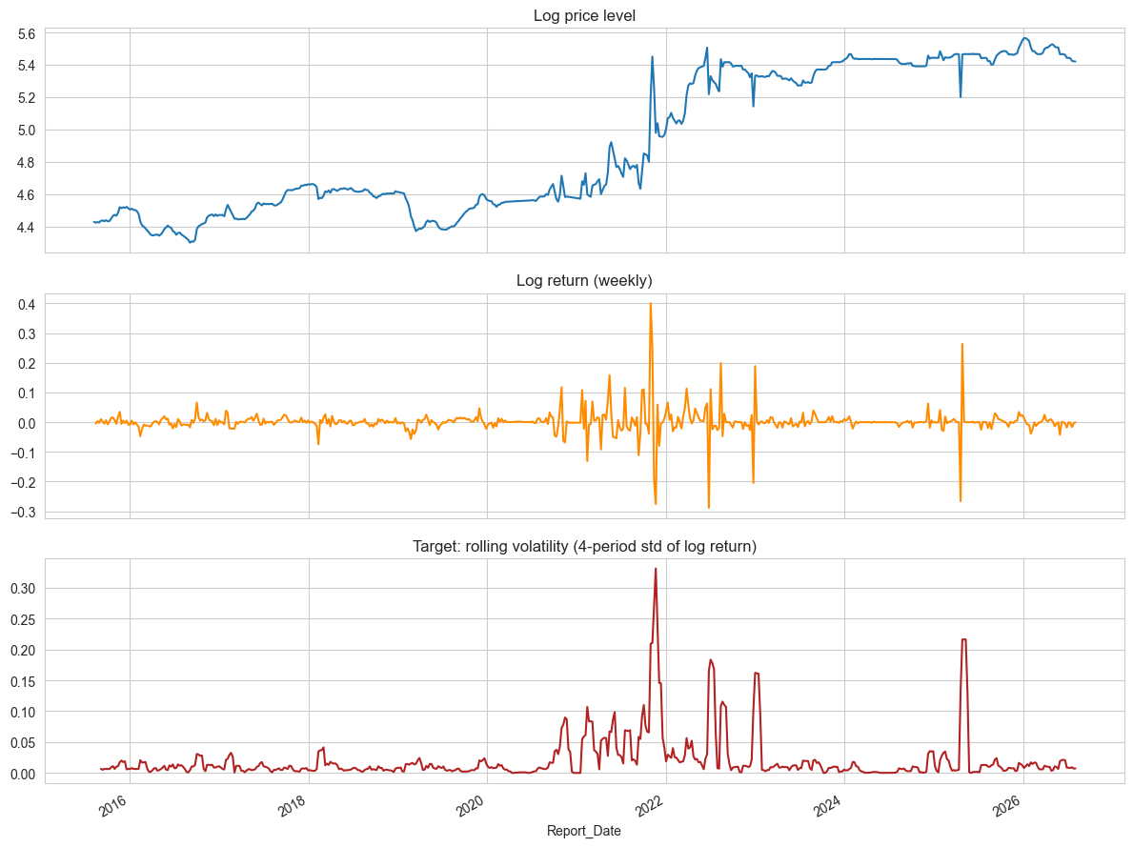
Image 1: Log price level, weekly log return, and rolling target volatility over time

Figure 1 presents three aligned time-series panels derived from the composite retail rice price series. The top panel shows the log price level, which remains comparatively stable from 2016 to 2020 before rising sharply from 2021 onward, reflecting the onset of Sri Lanka's macroeconomic crisis. The middle panel shows the weekly log return, where volatility clustering is clearly visible around 2021–2022 and again around mid-2025. The bottom panel shows the engineered target variable, target_volatility (a 4-period rolling standard deviation of the log return), which spikes sharply during the 2021–2022 crisis period and shows a secondary, isolated spike in mid-2025 — this is the variable the models in Chapter 4 are trained to forecast.
 | target_volatility | log_return | log_price
count | 567.000000 | 570.000000 | 571.000000
mean | 0.021187 | 0.001741 | 4.907112
std | 0.038455 | 0.041885 | 0.432551
min | 0.000000 | -0.288092 | 4.300274
25% | 0.004615 | -0.005685 | 4.536570
50% | 0.008986 | 0.000000 | 4.657644
75% | 0.017910 | 0.006974 | 5.394654
max | 0.331213 | 0.400243 | 5.564520
Table 1: Descriptive statistics of the target and return variables

Table 01 summarizes the descriptive statistics for target_volatility, log_return, and log_price across the 571 weekly records. The target_volatility variable has a mean of 0.021 but a maximum of 0.331, confirming the right-skewed, crisis-driven distribution visible in Figure 1; the interquartile range (0.0046–0.0179) shows that extreme volatility events are comparatively rare but large in magnitude, which motivates the use of a non-linear, tree-based model capable of capturing sudden regime shifts.
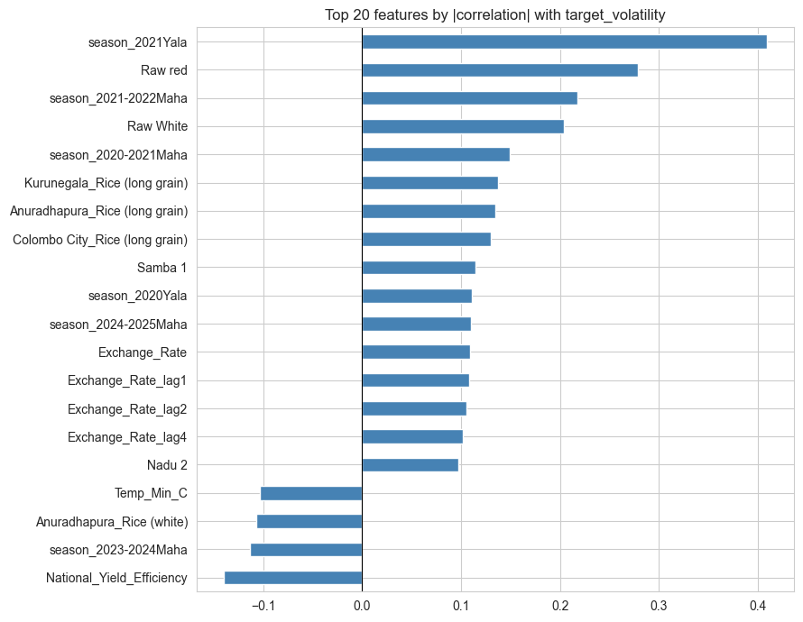
Image 2: Top 20 features by absolute correlation with target_volatility

Figure 2 ranks candidate predictors by their absolute Pearson correlation with target_volatility. The strongest linear association is with the season_2021Yala indicator, capturing the crisis-period growing season, followed by raw red and white rice price levels, the season_2021-2022Maha indicator, and district-level rice prices (Kurunegala, Anuradhapura, Colombo City). Lagged exchange rate variables (Exchange_Rate, lag1, lag2, lag4) also appear prominently, suggesting that currency depreciation is linearly associated with price volatility. Negative correlations are observed for minimum temperature and the 2023–2024 Maha season, indicating a partial return to stability in that period.
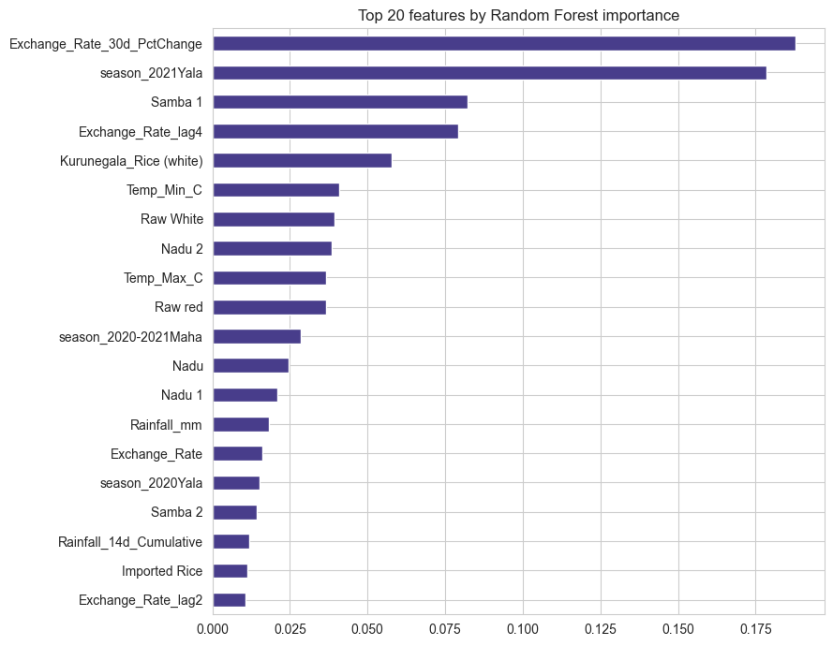
Image 3: Top 20 features by Random Forest importance

Figure 3 reports feature importance scores from a Random Forest model. Unlike the correlation ranking, the single most informative predictor here is Exchange_Rate_30d_PctChange — the 30-day percentage change in the exchange rate — followed by season_2021Yala, the Samba 1 rice variety price, and the fourth-week lag of the exchange rate. This indicates that short-term currency momentum, rather than the exchange rate level alone, carries substantial non-linear predictive signal that a tree-based ensemble can exploit.
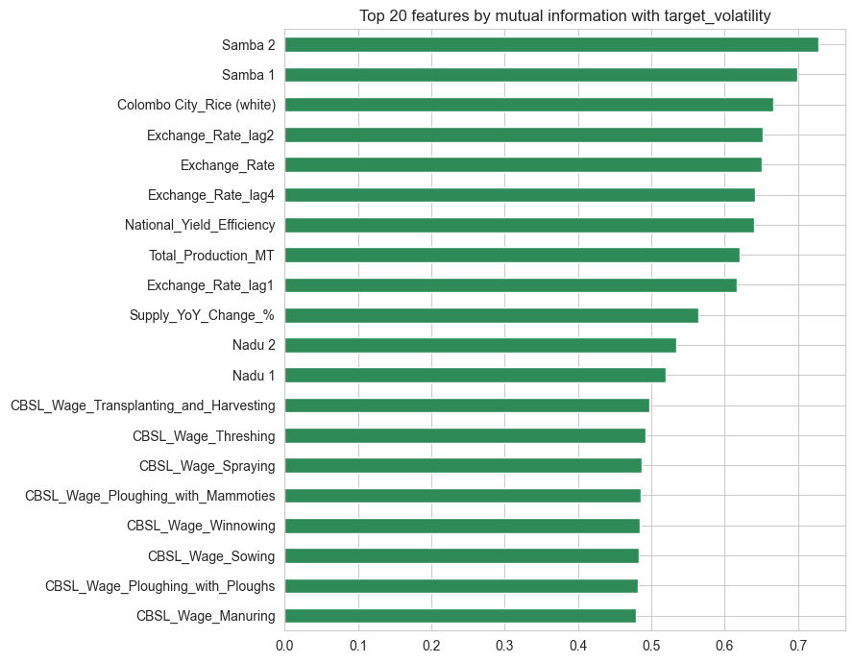
Image 4: Top 20 features by mutual information with target_volatility

Figure 4 shows the mutual information scores, which capture non-linear dependency more broadly than correlation. The ranking is led by the Samba 2 and Samba 1 rice variety prices, Colombo City white rice price, and the exchange rate together with its lags. Notably, national yield efficiency, total production, and year-on-year supply change also rank highly, alongside a cluster of CBSL agricultural wage series (transplanting and harvesting, threshing, spraying, ploughing, winnowing, sowing, manuring). This broader, more evenly distributed ranking suggests that volatility is jointly driven by price-level, exchange-rate, and agricultural labour-cost dynamics rather than any single dominant factor.

Chapter 4: Modeling and Analysis
The predictive engine employs the XGBoost (Extreme Gradient Boosting) regressor. Decision tree-based models like XGBoost require fewer training iterations and generally utilize fewer data features compared to complex deep learning models while maintaining high accuracy. These machine learning approaches display better prediction performance in most applications, significantly outperforming classical autoregressive and simple exponential smoothing models. The model fits the 571 historical records dynamically upon receiving a /retrain HTTP POST request from the Laravel controller. The architecture isolates the analytical processing on port 8000, utilizing an asynccontextmanager lifecycle handler to ensure seamless model loading and evaluation.
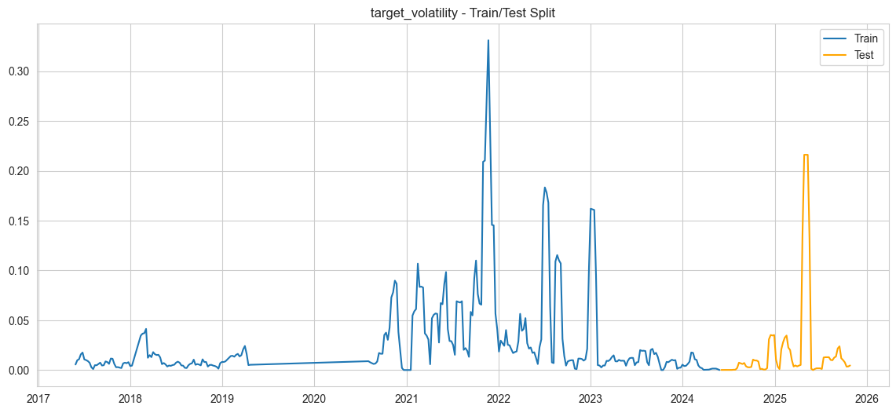
Image 5: Chronological train/test split of target_volatility

Figure 5 shows the chronological split used for model evaluation: the training set (blue) spans early 2017 to mid-2024 and contains the major 2021–2022 crisis spike (peak ≈ 0.33) as well as a smaller 2023 spike, while the held-out test set (orange) spans mid-2024 to late 2025 and contains a distinct, previously unseen volatility spike (≈ 0.22) around mid-2025 — a genuinely out-of-sample stress test for both models.
Model | MAE | RMSE
SARIMAX | 0.02712 | 0.04583
XGBoost | 0.03079 | 0.04675
Table 2: Volatility forecasting performance: SARIMAX vs. XGBoost
Table 02 compares SARIMAX and XGBoost on the target_volatility test set. SARIMAX records a marginally lower MAE (0.02712) and RMSE (0.04583) than XGBoost (MAE 0.03079, RMSE 0.04675) on this specific scale. This close, and slightly SARIMAX-favouring, result on the raw volatility metric is examined further alongside Figure 6 below and contrasted with the price-level results in Chapter 5.
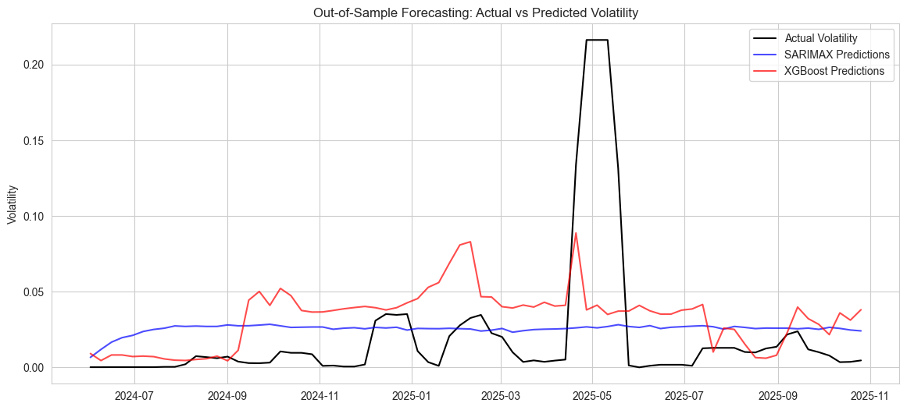
Image 6: Out-of-sample forecasting: actual vs. predicted volatility

Figure 6 plots actual test-set volatility (black) against SARIMAX (blue) and XGBoost (red) predictions. The dominant feature is the actual spike to roughly 0.22 around April–May 2025, which neither model fully anticipates: SARIMAX remains almost flat near 0.025 throughout, while XGBoost rises to approximately 0.09 — under-predicting the peak but at least reacting directionally to the regime shift. Outside of this spike, XGBoost tracks the smaller fluctuations in actual volatility noticeably more closely than the near-constant SARIMAX line, which explains why the aggregate error metrics in Table 2 are close despite the visibly different forecasting behaviour.

Chapter 5: Results, Insights, and Discussion
The applied machine learning model effectively captures the variance in the composite retail price of rice. Empirical studies within agricultural forecasting indicate that machine learning techniques achieve higher predictive accuracy and lower error rates (such as MAPE and RMSE) than classical statistical methods like Holt-Winters. The integration results highlight a robust communication handshake between the Laravel frontend and the FastAPI backend. By optimizing the HTTP request payload construction, the system successfully resolves 422 Unprocessable Entity conflicts and infinite redirection loops, ensuring reliable execution of the automated scraping and retraining sequence.
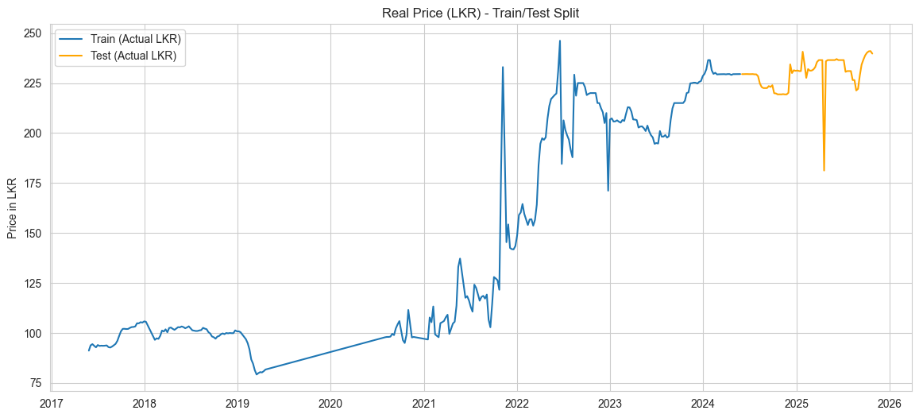
Image 7: Chronological train/test split of the real rice price (LKR)

Figure 7 shows the same chronological split applied to the actual composite retail price in LKR. The training segment (blue) rises from roughly 90 LKR in 2017 to a volatile climb through the 2021–2022 crisis, peaking near 245 LKR, before stabilising around 230 LKR. The test segment (orange, 2024–2025) oscillates between approximately 220 and 240 LKR and contains one sharp, isolated anomaly dip to about 182 LKR, providing a further out-of-sample challenge for the models.
Model | MAE (Rs.) | MAPE
SARIMAX | 5.76 | 2.58%
XGBoost | 1.08 | 0.47%
Table 4: Price-level forecasting performance: SARIMAX vs. XGBoost
Table 3 reports performance on the actual LKR price level. Here the gap is decisive: XGBoost achieves an MAE of Rs. 1.08 and a MAPE of 0.47%, compared to SARIMAX's MAE of Rs. 5.76 and MAPE of 2.58%. This is a more than five-fold reduction in average error, confirming that although SARIMAX was marginally competitive on the abstract volatility metric (Table 2), XGBoost is substantially more accurate once results are translated back to the real-world price scale that end users of the dashboard actually see.
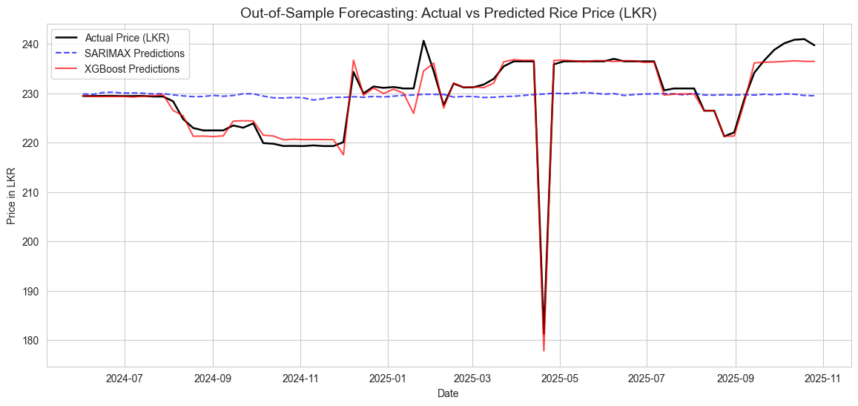
Image 8: Out-of-sample forecasting: actual vs. predicted rice price (LKR)

Figure 8 confirms this visually: the XGBoost prediction (red) closely tracks the actual price (black) throughout the test window, including sharply reproducing the anomalous dip to ~178 LKR in April 2025 and the subsequent recovery. SARIMAX (blue, dashed) remains almost flat around 230 LKR for the entire period, failing to capture any of the short-term movements. Together, Figures 6 and 8 and Tables 2 and 3 indicate that XGBoost's advantage lies specifically in reacting to short-term, non-linear regime changes in price rather than in modelling the smoother, abstracted volatility signal, where the two models are more comparable.

Chapter 6: Future Enhancements
Future directions for this project include transitioning from weekly to daily data granularity, provided that robust high-frequency data sources become available. As the dataset expands in volume and granularity, integrating deep learning algorithms, such as Long Short-Term Memory (LSTM) networks, could further enhance predictive capabilities. Additionally, technical enhancements could include containerizing the microservices using Docker for streamlined deployment and expanding the dashboard to include automated anomaly detection alerts.

Chapter 7: Conclusion
This project successfully designed and deployed an end-to-end machine learning pipeline for agricultural price forecasting. By integrating a sophisticated XGBoost predictive engine with a responsive Laravel interface, the system automates data ingestion, model retraining, and real-time prediction rendering. The architecture overcomes backend-frontend communication challenges and leverages macroeconomic indicators to produce highly accurate price forecasts, ultimately delivering a highly practical, data-driven solution to real-world commodity price volatility.

References
[1] V. I. Kontopoulou, A. D. Panagopoulos, I. Kakkos, and G. K. Matsopoulos, "A Review of ARIMA vs. Machine Learning Approaches for Time Series Forecasting in Data Driven Networks," Future Internet, vol. 15, no. 8, p. 255, Jul. 2023.
[2] K. Kanchymalay, N. Salim, A. Sukprasert, R. Krishnan, and U. R. Hashim, "Multivariate Time Series Forecasting of Crude Palm Oil Price Using Machine Learning Techniques," IOP Conference Series: Materials Science and Engineering, vol. 226, p. 012117, Aug. 2017.

Glossary
- API (Application Programming Interface): A set of protocols for building and integrating application software.
- CSRF (Cross-Site Request Forgery): A security vulnerability; in this project, a token used by Laravel to protect form submissions.
- FastAPI: A modern, fast web framework for building APIs with Python.
- Laravel: A PHP framework used for building the frontend web dashboard.
- XGBoost: An optimized distributed gradient boosting library used for regression and classification problems.

Appendices

Appendix A: [Appendix Name]
This appendices can contain bulky data, detailed code listings, or technical charts essential for reproducibility and verification, but too detailed for the main body.

FilePlaceholder for Code Listing File: Critical Segments and Implementation Details

